Program Statement:01 (30 marks)

==================

Attendance Report System using Servlets, JSP, JavaBeans, DAO Layer, and Oracle Database.

🎯 Objective:

Build a web-based application to add and view attendance records. The system follows MVC architecture, uses Oracle for data persistence, and applies standard Java EE practices with Servlets, JSP, and JavaBeans.

📌 Functional Requirements:

============================

Add Attendance Record

--------------------------------

.A JSP page (add.jsp) contains a form to collect Name, Date, and Status(Present/Absent).

.On submission, the form is posted to AddAttendanceServlet.

.The servlet constructs an Attendance JavaBean and passes it to AttendanceDAO.

.DAO layer inserts the data into the Oracle database using JDBC.

.The servlet redirects to the attendance report view (report).

View Attendance Report

----------------------------------

.AttendanceServlet fetches all records using AttendanceDAO.getAllAttendance() method.

.It stores the list in request scope and forwards it to report.jsp.

.The JSP displays the list in a tabular format.

🧠 JavaBean Usage:

-------------------------

Attendance.java

-----------------------

.Fields: name, date, status.

.Getters and setters to encapsulate attendance data.

.Used to transfer data between Servlet and DAO layers.

🔌 DAO Layer:

--------------

AttendanceDAO.java

-----------------------------

.getAllAttendance() – Fetches all attendance records from Oracle DB.

💻 Technical Constraints:

----------------------------------

.Use Oracle as the backend database.

.Use JDBC for database interaction.

Follow MVC:

-------------------

.Servlets = Controller

.JavaBeans = Model

.JSP = View

.Use POST for add operations.

.Use GET for view operations.

.Maintain clean DAO separation.

.Forward using RequestDispatcher and redirect using sendRedirect appropriately.

User Interface available below you can refer.

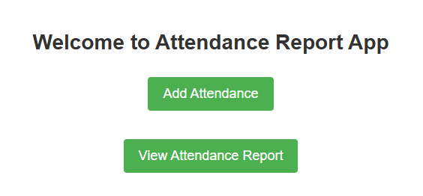

Home.jsp

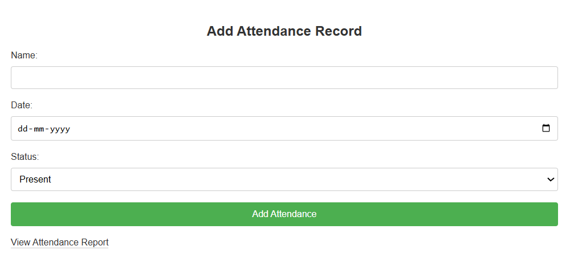

Add.jsp

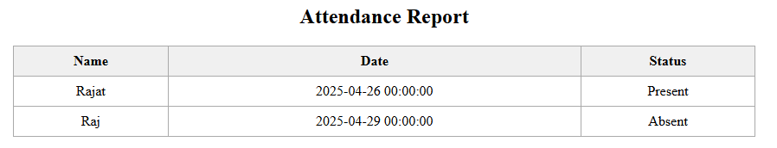

Report.jsp

Program 02: (20 marks)

===========

**Develop a Java Servlet-based web application that implements a simple user login system**.

**Requirements:**

* Create a LoginServlet that accepts POST requests with parameters username and password.
* Validate the user credentials against a hardcoded list of users stored in a HashMap<String, String> (username-password pairs).
* If login is successful, create an HTTP session and redirect the user to a welcome page (welcome.jsp) displaying the username.
* If login fails, forward the request back to the login page (login.jsp) with an error message.
* Implement session timeout of 5 minutes.
* Include logout functionality via a LogoutServlet that invalidates the session and redirects to the login page.